**DAILY ONLINE ACTIVITIES SUMMARY**

|  |  |  |  |  |  |  |  |  |
| --- | --- | --- | --- | --- | --- | --- | --- | --- |
| **Date:** | **13-07-2020** | | | | | **Name:** | **Likhitha.M** | |
| **Sem & Sec** | **6th Sem ‘A’** | | | | | **USN:** | **4AL17CS046** | |
| **Online Test Summary** | | | | | | | | |
| **Subject** | | **Cryptography, Network Security and Cyber Law** | | | | | | |
| **Max. Marks** | | **-** | | **Score** | | | **-** | |
| **Certification Course Summary** | | | | | | | | |
| **Course** | Python Data Structure | | | | | | | |
| **Certificate Provider** | | | **Coursera** | | **Duration** | | | **7 weeks** |
| **Coding Challenges** | | | | | | | | |
| **Problem Statement:**  1.Python Program for n\’th multiple of a number in Fibonacci Series | | | | | | | | |
| **Status:Completed** | | | | | | | | |
| **Uploaded the report in Github** | | | | | **Yes** | | | |
| **If yes Repository name** | | | | | [**https://github.com/likhithaMantaral/Daily-status**](https://github.com/likhithaMantaral/Daily-status) | | | |
| **Uploaded the report in slack** | | | | | **Yes** | | | |

Certification Course Details:

Python Data Structure – week 2

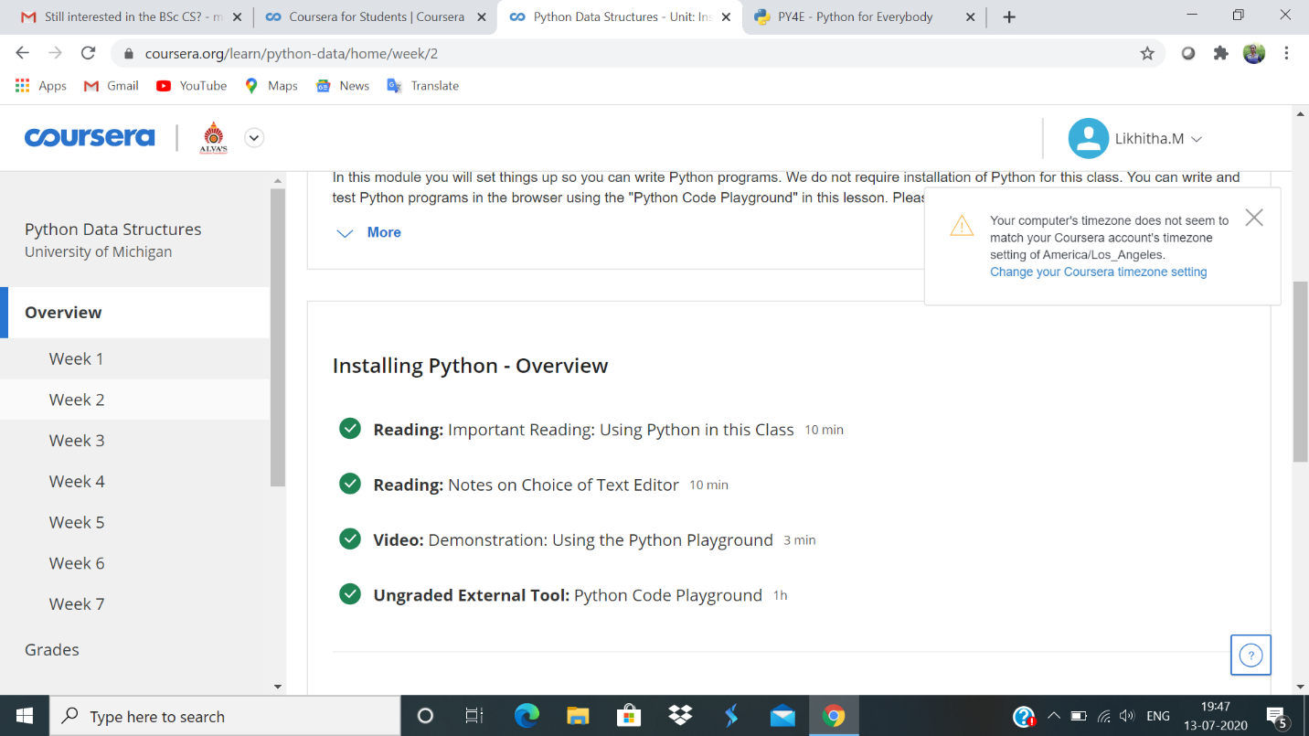

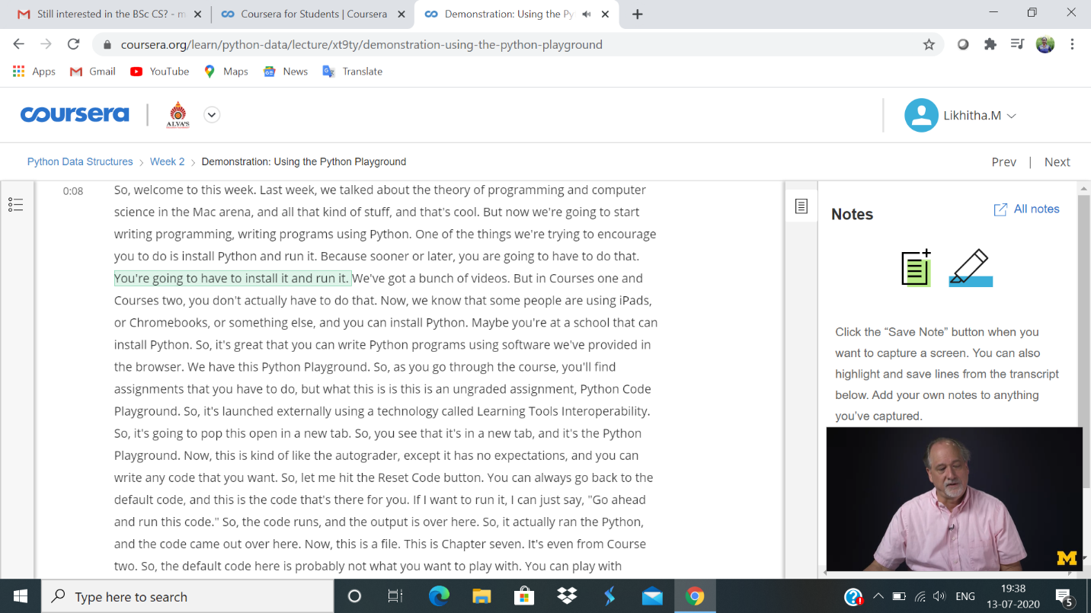

Online Coding Details:

